# 480/905: Activities 9-10

Online handouts: listings of Circle class files, private_vs_public.cpp, and square_test.cpp; "Using GSL Interpolation Functions", listing of GslSpline and test files, ode_test.cpp listing, CL mystery guide

In this session we'll take a further look at C++ classes, try out a GSL adaptive differential equation solver, briefly look at interpolation and cubic splines, take a first look at Python scripts for C++ programs, and do the "Command Line Mystery"

## Revisiting area.cpp with a C++ Class

Our first simple C++ code from Activities 1 used procedural programming, with the focus on the formula (which would typically be coded as a function) for calculating the area. Now we revisit it from an object oriented perspective. (We'll use "old" C++ and look at some differences with C++11 in Activities 10.)

1. Look at the online printout with test_Circle.cpp and the old area.cpp, with the Circle class definitions. Note how all of the details of the area calculation are now hidden. Any questions on the Class definition? Predict where in the test_Circle.cpp code the two circles will be created and where they will be destroyed. Why do we define get_radius and set_radius methods?   
     
   When we define get_radius and set_radius functions,the variable can be hidden in the class and only when someone need to use it,it can be used.
2. Using make_test_Circle, compile and link test_Circle.cpp with the class files. Run it and note where the circles are created and destroyed. Do you understand why they are destroyed in this order?   
   Yes,when a new circle is created,the last one destroys.
3. Add a method to Circle.cpp (and Circle.h!) so that we can get the circumfrence from my_circle.circumfrence(). Try it out in test_Circle.cpp. Did you succeed?   
   Yes.
4. Take a look at the private_vs_public.cpp code, which is a self-contained class and main program. Notice how the main program can access and change the x value and use the xsq function. But try changing from x to y in the statements getting, printing, and changing the value of x. What happens? Why does the get_y function work?   
   The program can still run.Because the x is only a name of variable in the class,which make no difference for the final result.
5. (Extra, only do this if you are fast.) Make a Sphere class with Sphere.cpp and Sphere.h, and try it out by adding to test_Circle.cpp to create a Sphere and print out its radius. Did you succeed?   
     
   Yes.

## Optimization 101: Squaring a Number

One of the most common floating-point operations is to square a number. Two ways to square x are: pow(x,2) and x*x. Let's test how efficient they are.

1. Look at the printout for the square_test.cpp code. It implements these two ways of squaring a number. The "clock" function from time.h is used to find the elapsed time. Each operation is executed a large number of times (determined by "repeat") so that we get a reasonably accurate timing.
2. We've set the optimization to its lowest value, -O0 ("minus oh zero"), to start in make_square_test.
3. Compile square_test.cpp (using make_square_test) and run it. Adjust "repeat" if the minimum time is too small. Record the times here. Which way to square x is more efficient?   
     
    Evaluating 100000000 pow(x,2)'s took 1.56946 seconds

Evaluating 100000000 x*x's took 0.537963 seconds

We can see that x*x is more efficient.

1. If you have an expression (rather than just x) to square, coding (expression)*(expression) is awkward and hard to read. Wouldn't it be better to call a function (e.g., squareit(expression)? Add to square_test.cpp a function:   
   double squareit (double x)   
   that returns x*x. Add a section to the code that times how long this takes (just copy one of the other timing sections and edit it appropriately, making sure to keep the "final y" cout statement). How does it compare to the others? What is the "overhead" in calling a function (that is, how much extra time does it take)? When is the overhead worthwhile?

Evaluating 100000000 pow(x,2)'s took 1.5698 seconds

Evaluating 100000000 x*x's took 0.540124 seconds

Evaluating 100000000 squareit(x)'s took 0.952655 seconds

It will cost about twice the original time.When the original time is not so long the overhead can be worthwhile.

1. Another alternative, common from C programming: use #define to define a macro that squares a number. Add   
   #define sqr(z) ((z)*(z))   
   somewhere before the start of main. (The extra ()'s are safeguards against unexpected behavior; **always** include them!) Add a section to the code to time how long this macro takes; what do you find?   
     
   It will cost a little more time than x*x,which can even be ignored.
2. One final alternative: add an "inline" function called square:   
   inline double square (double x) { return (x*x); };   
   that is a function prototype **and** the function itself. Put it up top with the squareit prototype. Add a section to the code to time how long this function takes. What is your conclusion about which of these methods to use?   
     
   We can conclude that calculating x*x directly is the fastest.To avoid coding complex name of x,we can set a function to return the result of x*x,but coding the function will take some time.So the best choice is to define the function.
3. Finally, we'll try the simplest way to optimize a code: let the compiler do it for you! Change the compile flag -O0 (no optimization) to -O2 (that's the uppercase letter O, not a zero). Recompile and run the code. How do the times for each operation compare to the times before you optimized? What do you conclude?   
     
   All of them get faster.But what is strange is that x*x becomes the slowest.
4. In your project programs, once they are debugged and running, you'll want to use the -O2 (or maybe -O3) optimization flag.

## GSL Differential Equation Solver

The program ode_test.cpp demonstrates the GSL adaptive differential equation solver by solving the Van der Pol oscillator, another nonlinear differential equation (see the Activities 10 background notes for the equation).

* 1. Take a look at the code and figure out where the values of mu and the initial conditions are set. Change mu to 2 and the initial conditions to x0=1.0 and v0=0.0 (y[0] and y[1]). Note the different choices for "stepping algorithms", how the function is set up and that a Jacobian is defined, and how the equation is stepped along in time. Next time we'll see how to rewrite this code with classes.
  2. Use the makefile to compile and link the code. Run it.
  3. Create three output files using the initial conditions [x0=1.0, v0=0.0], [x0=0.1, v0=0.0], and [x0=-1.5, v0=2.0] (just change values and recompile each time). Notice how we've used a stringstream to uniquely name each file.
  4. Use gnuplot to make phase-space plots of all three cases on a single plot, noting where they begin and end. Sketch it and describe what you observe. This is called an **isolated attractor**.   
       
     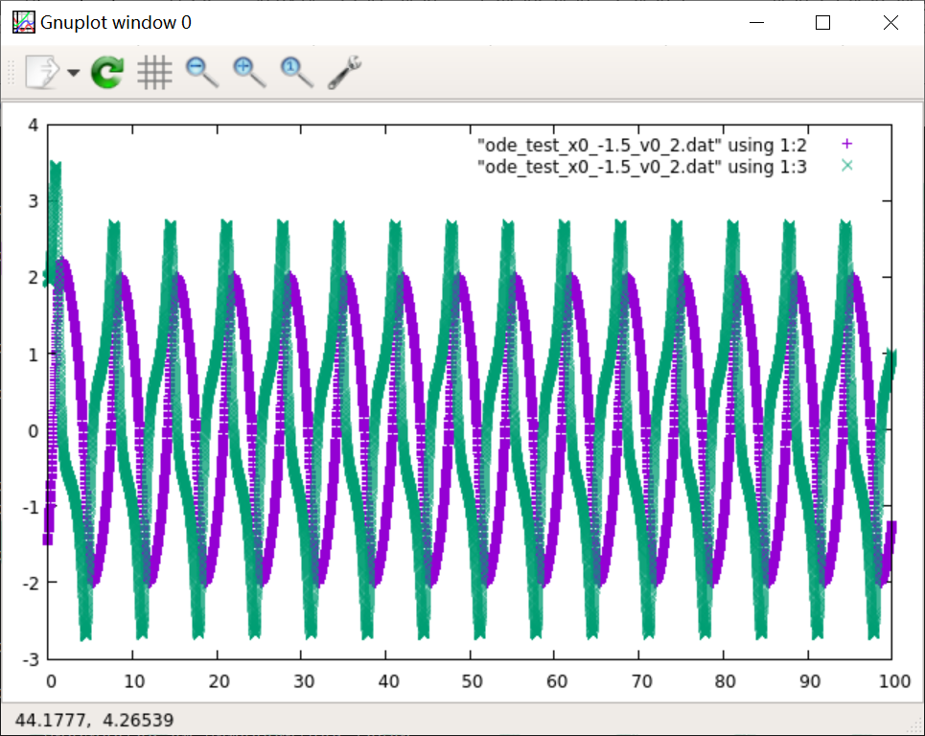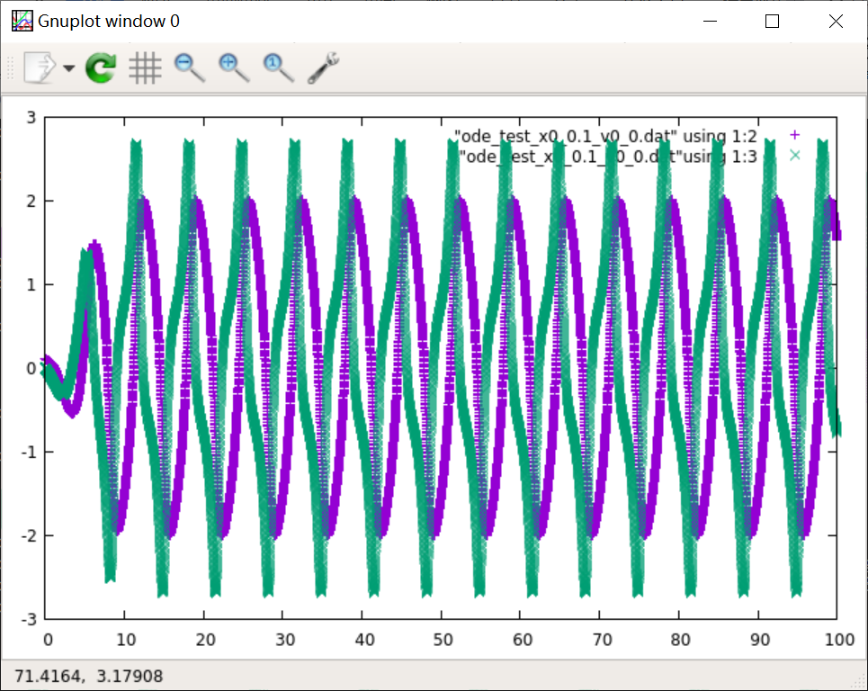  
       
     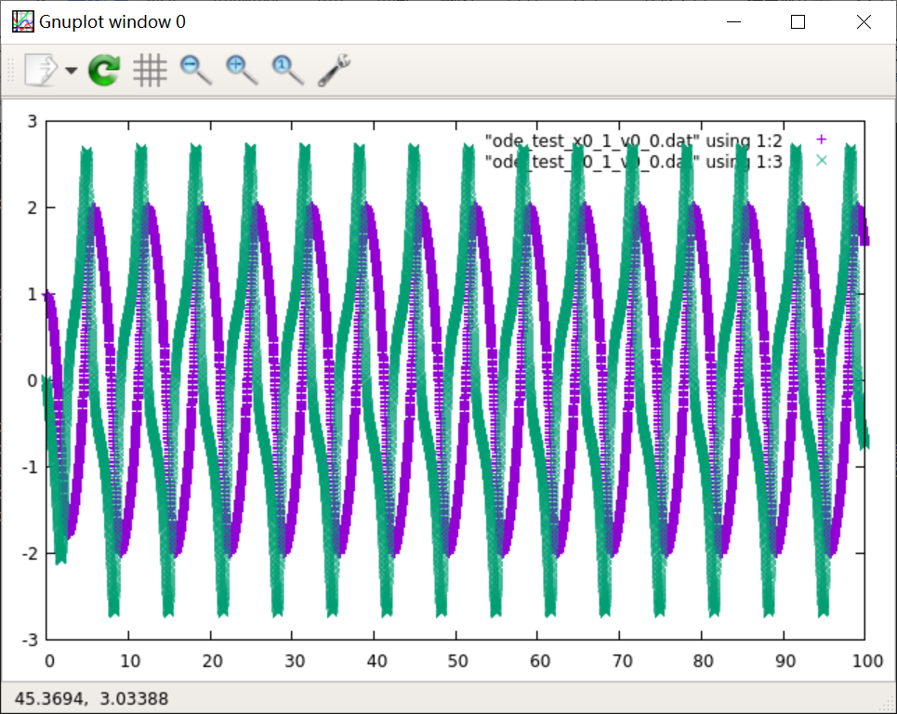

They look very similar,like sin function but with the different phase.  
And they are a little twisted.

* 1. Think about how you would restructure this code using classes. Next time we'll explore a possible implementation that is described in the Activities 10 notes.

## GSL Interpolation Routines

We'll use the example of a theoretical scattering cross section as a function of energy to try out the GSL interpolation routines. The (x,y) data, with x-->E and y-->sigmath, is given in the bottom row of the table in section 10c of the session notes (note we are NOT fitting sigmaexp). You might think we should be doing this for the experimental cross section. Usually we will fit rather than interpolate such data because it is noisy and we also want to validate our interpolations against known functions.

* 1. Start with the gsl_spline_test_class.cpp code (and corresponding makefile). Take a look at the printout and try running the code. Note that we've used a Spline class as a "wrapper" for the GSL functions, just as we did earlier with the Hamiltonian class. Compare the implementation to the example on the "Using GSL Interpolation Functions" handout. Questions?

No question.

* 1. Instead of the sample function in the code, you will change the program to interpolate the data in the table from the notes. This will require deleting some of the code and adding new lines. Set npts and the (x,y) arrays equal to the appropriate values when you declare them. Declare them on separate lines. An array x[4] can be initialized with the values 1., 2., 3., and 4. with the declaration:   
     double x[4] = {1., 2., 3., 4. };
  2. Use the code to generate a cubic spline interpolation for the cross section from 0 to 200 MeV in steps of 5 MeV. Output this data and the exact results from equation (10.7) in the notes to a file for plotting with gnuplot and try it out. Plot the exact results "with lines" and the spline using "with linespoints" (or "w linesp"), so you can see both the individual points and the trends.
  3. Now modify the Spline class to allow for a polynomial interpolation (see the GSL handout) and change the gsl_spline_test_class.cpp main program to generate linear and polynomial interpolations as well and add code to print the results to your output file. Did you succeed?   
       
     Yes.
  4. Generate a graph with all three interpolations plotted along with the exact result. Comment here (a sketch might help) on the strengths and weaknesses of the different interpolation methods, both near the peak and globally.

## Command Line Mystery

The "Command Line Mystery" is a whodunit designed to give you some practice with useful shell commands and how to string them together (with "pipes"). Follow the instructions on the clmystery handout. Did you solve the mystery?

Yes.

## Python Scripts for C++ Programs

This exercise is just a first exposure to what is possible with Python scripts. The listings for the scripts and revised versions of the area.cpp C++ programs are in the Activities 10 notes.

1. Look at area_cmdline.cpp first and try it out (there is a makefile), first omitting an argument when executing it. Then look at and try run_area_cmdline1.py. Change the list of numbers to generate the area for radii from 5 to 25 spaced by 5. Did you succeed?

Yes.

1. Modify both area_cmdline.cpp so that it takes two arguments, the radius and an integer called again. Change the code so the output line is repeated again times. Modify run_area_cmdline1.py so it works with this new version. Did you succeed?

Yes.

1. Try out run_area_cmdline2.py, modifying value_list1 and value_list2 to help you understand how they work. Questions? [Note: this might fail on Cygwin]

No question.

4.For now, just look through run_area_cmdline3.py and try running it. Note the use of findall and sorting, which may come in handy later.

5.Look at area_files.cpp and try it out (there is a makefile). There is also a Python script, run_area_files2.py, to try. (CHALLENGE) Modify the program and script so that the input file has an extra column for the integer again introduced in part 2.

## Cubic Splining

Here we'll look at how to use cubic splines to define a function from arrays of x and y values. A question that always arises is: How many points do we need? Or, what may be more relevant, how accurate will our function (or its derivatives) be for a given spacing of x points?

* 1. We'll re-use the Spline class from the last section and the original gsl_spline_test_class.cpp function, which splined an array.
  2. The goal is to modify the code so that it splines the ground-state hydrogen wave function: u(r) = 2*r*exp(-r)
  3. Your task is to determine how many (equally spaced) points to use to represent the wave function. Suppose you need the derivative of the wave function to be accurate to one part in 106 for 1 < r < 4 (absolute, not relative error) Devise (and carry out!) a plan that will tell you the spacing and the number of points needed to reach this goals. What did you do?

I change the output to precise(8).

* 1. Now suppose you need integrals over the wave function to be accurate to 0.01%. Devise (and carry out!) a plan that will tell you the spacing and the number of points needed to reach this goals. To try out integrals, use one of the GSL integration routines on an integral involving the splined u(r) that you know the answer to (hint: what is the total probability?). Note: The qags_test.cpp program from the Activities 4 files can be quickly adapted for this exercise.